Monday November the 8th 2021 Hearing
By SILVANA MOSSANO
(precede by her comments in Italics)
I had a strong temptation to summarize the eighteen witnesses in the hearing on Monday 8 November, against Stephan Schimdeheiny (…). The temptation was to shape them into a single story, (..) filtering detail through the 'whole', smoothing the edges, forgetting the details, making the tragedy a little more bearable. A formula for human self-protection (so I tell myself, invoking a absolution), but at the same time a cowardly way out (in the end I admitted it to myself, roughly awaking my conscience.
I was tempted to tell the story from behind the threshold, taking a step back in listening and reporting those voices. Why? Because it is like entering your own home, where you know what has happened and what is happening, you know what it feels like, you know how it stuns you - the back of your neck, your shoulders, your throat and your bowels - the chill of despair, of inevitability and powerlessness. You know what the anguish, fear and resignation look like when you receive the fierce diagnosis of mesothelioma. Scientific definitions are of little importance: malignant, pleural, biphasic, sarcomatoid... Mesothelioma is already everything. Too much. But those voices - of wives, of children - so polite and calm that rose from behind the table in the courtroom shock me more than the thunder of an August thunderstorm, throw open the doors and windows, forcing me to cross the threshold, to listen again, word for word, and to relive, unsparingly, every reaction and feeling. I had to listen to all the voices (…) out of respect, out of love, out of memory.

The lawyers for the victims and relatives who spoke on the 8th of November 2021

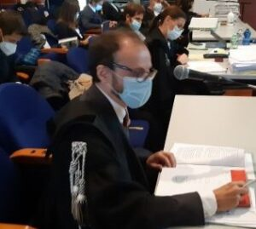
Lawyer Enrico Brunoldi
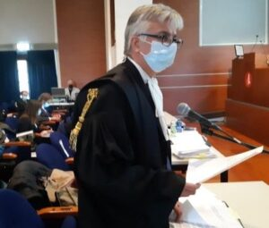
Lawyer Maurizio Riverditi
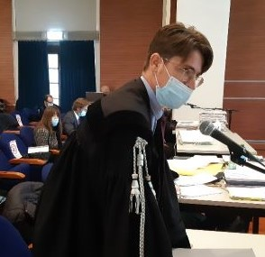
Lawyer Paolo Liedholm
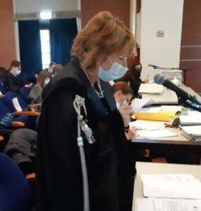Lawyer Esther Gatti
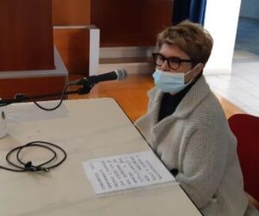
Paola Maria Leporati for the death of her mother Maria Raiteri (Lawyer Enrico Brunoldi)

"She was my mum. She had always lived in Coniolo, about six kilometres from Casale. As a girl, she was a farm hand; after marrying my father, she started working in her in-laws' bakery, which my father took over in 1972, leaving his job as a worker at Eternit where he had developed asbestosis: I remember his breath whistling and how it made it difficult for him to fall asleep. Mum devoted her whole life to her family and her work. She always helped me, especially after the birth of my son, in 1995, as a he is slightly disabled". With her grandson, who is beautiful and very sweet, as a grandmother she developed a powerful and special relationship, she was a constant and important presence. "In August 2008, she started to feel pain in her lower abdomen; I asked a friend for an ultrasound scan. "I don't like it so much," he told me after the examination, "have more tests done”. In October the diagnosis came - relentlessly. She began to suffer from shortness of breath. We talked to Dr. Daniela Degiovanni (the oncologist who directed the Hospice Zaccheo in Casale and the Vitas association for years, ed.) and agreed not to have chemo, to ensure the best possible quality of life. At home, I learned to do what I had to do and I treated her according to the instructions I was given. She withdrew into herself, regretting that she could no longer be useful. In the last week, when the situation got worse, I decided to transfer her to the hospice, so that my son would not have to suffer directly from the death of his grandmother, to whom he was very attached. There, at the hospice, we were close, surrounded by affection, like being at home, in a family".

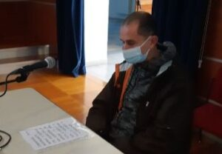
Paolo Scarrone (lawyer Brunoldi) for the death of his father Mario Scarrone.

"My father lived in San Germano, just outside Casale, until 1961; then he moved to town and opened a shop household commodities as you had then, in Via Garibaldi, together with his sisters. The first symptoms of the disease appeared in March 2008: he struggled to climb the stairs and was always out of breath. After x-rays and other checks, mesothelioma was diagnosed. He was a sportsman, my father; as a young man he even played tamburello, as an amateur, in the indoor ball-court in Corso Indipendenza (along the route from the Eternit plant, at Ronzone, to the warehouses in Piazza d'Armi, ed.). Even when he got sick, for a while he continued to go to the Natal Palli stadium for the matches of Casale or to Milan to cheer Inter, until ... My mother took care of him and was close to him, from the beginning until he died in July 2009".

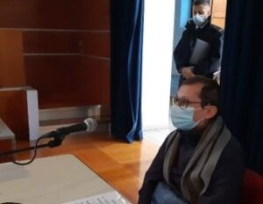
Massimo Mazzer (lawyer Maurizio Riverditi) for the death of his mother Carla Lunati.
"My mother worked at Eternit for 32 years; in the last period she made chimney covers, what we called chimney "hats", she modelled them with her hands. The blue overall? She wore in the plant and from home to the factory and vice versa, on the way back. Who washed it? She washed it herself. She had always lived in Casale. And when you're from Casale and you have certain symptoms...you worry. She took early retirement because she had asbestosis. The dust in her lungs. She couldn't breathe properly, she slept practically sitting up, with two pillows firmly behind her back. “But the disease that killed her," her son told the court, (…) "was not asbestosis, but mesothelioma. It appeared in July 2003. The first symptom: intestinal problems. While they were preparing her for the tests, she heard a nurse say to the doctor, 'she's a 71-year-old woman who worked for a long time at Eternit'. And my mother understood: if you live in Casale, you know what that means!".
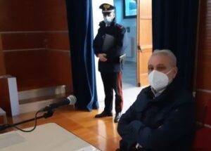
Roberto Beccaria (lawyer Riverditi) for the death of his mother Elda Costanzo.
"When I was young, my mother was a shirt-maker; then she worked in a newspaper distribution office and finally she was a school janitor. She also took care of the house, and even the laundry, including washing my father’s dusty overalls of my father. He was a worker at Eternit from the 1960s until it closed in 1986. Once the diagnosis was made, my father, who looked after her throughout her illness, from August 2008 to 4 February 2009, chose not to tell her what was wrong with her: she was very apprehensive, she couldn't take it. When my son was born, my mother was overjoyed to be able to look after her grandson; she wanted to see him grow up. But when she died, he wasn't even eight years old. He is asked if powder was used in the courtyard: "Yes," he replies, "it was used to 'stabilise' the surface and, just by walking on it, you raised dust at every step".
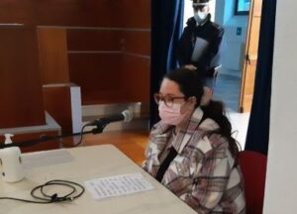
Beatrice D'Ambrosio (lawyer Riverditi) for the death of her father Walter D'Ambrosio.
"My father was a very young man, active, he went hiking. He had lived several years in Casale, when he worked in a bank, then he moved to Vercelli, but he often came back to the city, because all his friends and his brother lived there, in via Cavour, in the centre. In September 2013, he developed bronchitis ". That was the first guess. "Between October and November, however, the diagnosis of the real disease was made." Mesothelioma. "My dad didn't react well," recalls the daughter, "my mum had already died of cancer and he immediately realised he had no future. Of all the activities he did, well... he couldn't do anything anymore. In January, they tried chemotherapy, but he couldn't even receive the third dose, because he was too sick. He died in April 2014."
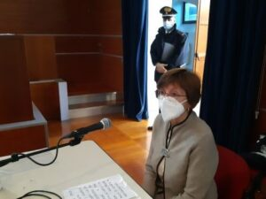
Assunta Prato (lawyer Riverditi) for the death of her husband Paolo Ferraris.
"He was my husband, we got married in 1975. When he died, he was not yet 49 ". Assunta and Paolo had always lived together in Casale, where he (who was head of the research Office of the Municipality of Alessandria, close by) and was actively involved in politics, holding important roles in the Casale local administration and, later, also in the region (he was both a councillor and alderman). "The first symptoms appeared at the end of 1993: a bit of a cough, but it seemed trivial. However, it didn't go away. In March they decided to carry out further tests and the diagnosis was: mesothelioma. Was he aware? "At the beginning, he probably was " explained the widow, "even though the name of the disease was preceded by the adjective 'probable' and 'not established'. They advised us to go to the San Luigi hospital in Orbassano to see if surgery was possible”. The memory is painful; for every detail she relives, her voice fails her. "The consultant took me aside, confirmed the diagnosis and told me that, in his opinion, it was better not to do anything: neither surgery nor chemotherapy, because in both cases the quality of life would have been severely compromised. But he added another suggestion: don’t tell him the truth. "I replied that Paolo would never have believed such a lie. Paolo Ferraris was part of the team of the then mayor Riccardo Coppo who, in 1987, had issued the order banning any use of asbestos (production, processing, marketing) in Casale, the first town in Italy and five years before the national law. Paolo Ferraris knew perfectly well how serious asbestos cancer was. Indeed, as a public administrator, in 1994 he managed to get the Piedmont Region to allocate the first three billion lire, to begin the reclamation work in the Casale area. "But the head physician told me that, if I felt like it, he was willing to back up the thesis of a ‘probable meso’ with an ambiguous piece of paper to give to the attending physician. Assunta Prato agreed to bear the whole burden alone, shared with only a few trusted friends. "When we left the Orbassano office, Paolo felt consoled, because he had feared the diagnosis of mesothelioma and instead... He put the paper that the surgeon had given him into my hands, "you give it to our doctor". Two years went by in this way: "At first, his quality of life was quite good, but then the situation began to worsen, with pain, lack of strength. He had lost 25 kilos. The evil disease gnawed away at him with implacable voracity. "I didn't say anything to our three children either, but the time came to tell them everything. And immediately afterwards, in August '96, I told Paolo as well". And how did he react? Up to this point, Assunta Prato's memory has taken the form of a flat and measured narrative, with the respectful and empathetic attention of judges and lawyers, involved in all these painful stories lined up like a black and white film, dotted with the colours of lives lived. How did Paolo Ferraris react? Assunta Prato knows very well how her husband reacted and her weeping. At first she speaks quietly, then, bursts out, tears swell in her throat and she seizes up, gasping and sobbing. “He told me," as she recovers her voice, "that I had given him two years of life. In his last days, 'when he could no longer stand on his own two feet, apart from me, our children helped him to move, right up to the last day'. He died on 2 December 1996 in their home.

Maria Grazia Rosso Chioso ( lawyer Paolo Liedholm) for the death of her husband Giovanni Numico.
"He was my husband of 35 years: the ideal companion, with whom I shared a full life, my point of reference. I am still lost without him". Numico, an entrepreneur from Casale, was first co-owner of a wholesale food and colonial goods warehouse, and then a partner in the Diffusioni Grafiche printers until 2002, when he concentrated his business on managing newspaper distribution in the Verbano area. "He began to feel unwell in November 2004: he had a great pain in his back which, despite treatment, would not go away. On 12 January 2005, he had an X-ray and it turned out that he had water in his lungs. That was the beginning of the whole ordeal. When he was told of the diagnosis, 'he told the professor: "I need seven months to get things in order, to sort out the family business"'. His main thought was to ensure every possible protection for his wife and daughter. He asked for seven months, he was no longer interested in anything else," said Maria Grazia Rosso Chioso, "and when they told him that the disease had "stopped" during the various examinations, he replied, resignedly, that his time was up. He died on 1 June 2006. He also left a sum of money for research: the association 'Oltre il Mesotelioma' was founded in his memory.
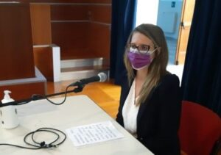
Sonia Bonino (lawyer Esther Gatti) for the death of her father Massimo Bonino.
"My father was a sportsman, he was slim and healthy: he rode a bicycle and had a motorbike. He had a passion for music. He played in a band, even at weddings and festivals. He cultivated his passions in his spare time. He worked as a salesman for bakery ovens and refrigeration systems for shops and bars. He lived between Casale and Vercelli, but he always went back to Casale, both for professional reasons and because he had his mother, younger sister and uncle here, as well as his friends and hobbies". All that went well until, one day between November and December 2009, a cough appeared and became more and more insistent. "My father was a hypochondriac and reading in Monferrato (the local bi-weekly, ed.) the news about people who were ill with mesothelioma made him aware and worried at the thought that he too might...'. And so it happened: after the diagnosis in early 2010, he went under a surgical team in Brescia: 'In March, the diseased lung was removed. After the operation, he was never well again, but somehow managed to get by, until May 2011, when the suffering was weighing heavily on him, he was in great pain, he was struggling to breathe because his lungs were full of water, and he couldn't get dressed. He said that, knowing this, it might not have been the right idea to have the surgery". From the beginning he had no illusions: he knew he was going to die. But after the initial shock, he became super-rational: he made a living will and settled everything with the bank and the insurance company. He also went to the Hospice in Casale to gather information personally, right from the start, knowing of the fate that awaited him; he feared physical suffering. And there he asked to be cared for when the time came, because he did not want to burden his family". In the last few months, chemotherapy was also tried, "but it was ineffective on such a weakened body: he weighed 45 kilos! When he was finally admitted to the hospice, "he had great difficulty breathing and eating. He died in July 2011'. The sportsman & musician Massimo Bonino was 57 years old when he died.
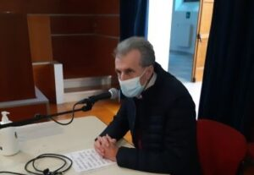
Marco Scagliotti (lawyer Riverditi) for the death of his mother Rosa Grangia.
"My mother was an energetic woman, a smart one, who lived in Rolasco, just outside Casale, very close to Eternit as the crow flies. She was a housewife, but she also had an orchard, the vegetable garden and had a beautiful garden". The signs of illness appeared at the end of 2014. "It happened one bad evening," recalled her son, "I will never forget it. December the 17th . I was having dinner with some colleagues out of town. She phoned me. Strange, I thought, that was out of character. "She said, "Marco, I have a lot of pain in my right side. I was a hundred kilometres away, the emergency services went, then an ambulance took her to the emergency room at the hospital. I arrived at the hospital at one o'clock in the morning and learned that there was a major pleural effusion. I didn't understand it at the time. In the days that followed, after the CT scan, Dr Piccolini, the pulmonologist, performed a thoracentesis. When she was discharged, they gave me a piece of paper with the words 'malignant biphasic mesothelioma' written on it'. And how did your mother react? "Initially with hope; she asked me: "Marco, do you think I'll get through this?". A month later she was already less hopeful: "Here I think I'm going to end up like Laura", a woman she knew who had died of mesothelioma. In June, she was shaking her head: 'I'm the sort of woman who stops at nothing!'. Until one day, looking at herself in the mirror, she commented: "Go on, go on, what a Via Negri face I've got!" (Via Negri is where the Casale cemetery is located, ed.). She lived six months from the diagnosis, half spent in hospital.
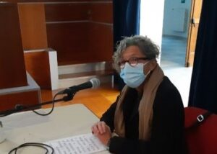
Maria Paola Soffiantino (lawyer Riverditi) for the death of her mother Gianfranca Piano.
"My mother was born in Sala, but she spent most of her life in Casale, except for a period in Ivrea. I remember, she used to say that "there's a lot more dust here in Casale than in Ivrea!". She was first a housewife and then sold food containers and pots and pans, door to door to farmers'. The symptoms of the disease appeared in the summer of 2002: 'She had abdominal pains and struggled to breathe. In September, fluid was found in her lungs. It was analysed, and twice with negative results. What can we say? The investigations continued, including a biopsy that confirmed the fears: 'The diagnosis - sarcomatous pleural mesothelioma - was announced on 8 November 2002'. Maria Paola Soffiantino pauses for a moment and reflects, then: "Yes, today (the day of the hearing, ed.) is the same date as nineteen years ago. Her memory is sharp: 'My mother knew everything about the seriousness of the illness and the certain end. For a few months, she was self-reliant: she walked, looked after herself, kept herself tidy, watched TV and read. Until November 2003, when she was given a home help and needed oxygen. She no longer cared about her big garden or the mountains. She had one worry: 'Will I be able to spend Christmas with my children and grandchildren?” She died on 21 December 2003.
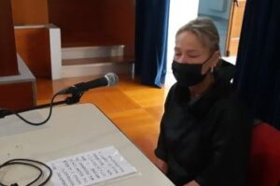
Alessia Natta (lawyer Riverditi) for the death of her mother Giovanna Buso.
"My mother was widowed when my father died and remarried. Her second husband worked at Eternit, he was a worker at the plant from 1963 to 1986. Who washed his overalls? She did, of course, and, indeed, before putting them in the washing machine, she shook them well because they were so dusty'. The 'terrible ordeal' began in 2007: 'She had a lot of pain in one arm and one shoulder. She was examined, she had a CT scan, but nothing came of it. Yet things weren't going well, she was seriously struggling to walk. She had another CT scan in Alexandria and this "beautiful" spot on her lungs came out. And what was 'this beautiful spot'? "It was mesothelioma. My mum had great difficulty moving and underwent spinal surgery, but after a few months she was completely paralysed, except for her head and hands. She was lucid. She was lucid and conscious until an hour before she went into a coma and died. My daughters and I took care of her, one was at high school and the other at university, we took turns. I didn't know what to tell my mother when she looked into my eyes...'. Other fatal fibres had already struck this family: 'My grandfather, my mother's father, who had worked at Eternit, had also died of the same disease. When he retired, he left his job at the factory to his son, my uncle. He also met the same end’.

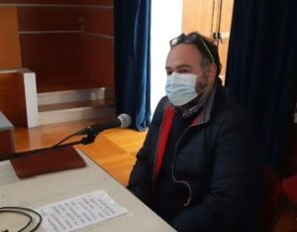
Andrea Chiesa (lawyer Riverditi) for the death of his father Domenico Chiesa.
"When he was a boy, dad was as a sausage factory worker in Casale. Then, at the beginning of the 1960s, he changed jobs and became an insurance agent". The first office was in Via Liutprando, then they moved to Piazza Castello (700-800 metres from the Eternit factory) in 1976: one of the best-known insurance agencies in the city. "In June 2011, the first symptoms appeared: shortness of breath, coughing, back pain. One day," his son recalls, "while he was in the garden, he felt dizzy and fainted. He was taken to the hospital 'and that's when it all started: during the check-up something was noticed in his lungs'. The diagnosis was clear. "Within a few months, between August and November, he lost weight and autonomy. Yes, Dad knew what was happening, but we didn't talk about it. He used to like meeting people, tending the garden. With the illness, he couldn't do it anymore. He died on 11 November 2011.
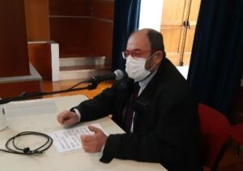
Davide Sorisio (lawyer Riverditi) for the death of his mother Marisa Petrini.
"My mother, originally from Ponzano, moved to Casale when she got married. She was a primary school teacher: she taught at the XXV Aprile school, in Oltreponte, and at the Martiri school, in Piazza Castello. How far away from Eternit? Well, about a kilometre and a half, maybe less. She was also took Sunday School and Catechism at the local parish church. She died of mesothelioma on 22 February 2015. "Between the end of August and September 2012, she began to experience shortness of breath, increasing fatigue and exhaustion. She was out of breath. One day," recalls her son, "when she came home after a short walk, I noticed that she was... how should I put it... hungry for air, and for at least half an hour she couldn't breathe. We decided to have test done, in Casale and Novara, and the result came back. Did she know? "She demanded it: 'Whatever you need,' she admonished me and my sister, 'let me know. For a while she retained a certain independence, 'but not in the terminal phase, she needed more and more help'.
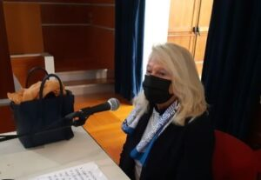
Paola Perotto (lawyer Paolo Liedholm) for the death of her mother Santina Caprioglio.
"My mother was a housewife. My sister and I counted on her a lot, even when we started a family. She was born in San Giorgio Monferrato, but when she married my father, to whom she has always been very attached, she moved to Casale. We lived in Corso Indipendenza. It was one of the busiest streets with the trucks that drove from the Eternit plant in Ronzone to the warehouses in Piazza d'Armi coming and going, and the railway station nearby. "Of course I remember the trucks, with two trailers, carrying the sheets, and there was no protective tarpaulin. Sometimes, on the curve, part of the load would fall down and break. The drivers themselves would get out and sweep it up with a broom, raising quite a lot of sust". Something unusual happened in the summer of 2001, "while we were on holiday in Varazze. Mum lost a lot of weight and, if she took even two steps, she would go was short of breath". Since she had a family history of heart disease, she had an electrocardiogram, but the doctor also suggested a pulmonary examination. Her health was gradually deteriorating. "We were very worried; Dr Piccolini, the pulmonologist, agreed to see her on December, the 8th, despite it being a holiday in Italy. He said nothing when he saw her. Then he phoned me and my sister and explained that one of her lungs was half filled with fluid. At the hospital, they took a CT scan and performed a bronchoscopy, and told us that even before the results came back, the colour of the fluid taken from the lung could give an indication. Unfortunately, the colour of the fluid taken was the "wrong" one. During the bronchoscopy, while I was in the corridor, I heard my mother's cries. I ran into the chapel and prayed: I prayed that it wasn't "that". But it was. "My sister and I agreed with the doctor that it was better not to let her know: if she had known what she really had, she would have thrown herself out of a window. We decided to tell her she suffered from neglected pleurisy; we stuck to that explanation, she was prescribed some treatment and for a while it had some effect. But the doctors had told us: 18 months to live. They were not wrong. In the very hot summer of 2003," continues the daughter, "we took mum to the mountains, we thought it would do her good; instead, she got worse, she was gasping for air. We went home; she needed oxygen, and in the last fortnight she was almost unconscious. She died on August the 30th 2003 in her bed. And you? "I live in fear. My generation has seen so many people die of mesothelioma, even people my age. In the building in Corso Indipendenza where my parents lived, at least four or five people, as far as I know, have died of mesothelioma".
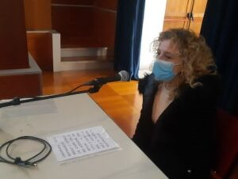
Barbara Sarzano (lawyer Esther Gatti) for the death of her mother Graziella Martinelli.
"My mum was a seamstress. Repairing clothes. Ours was a very, very closely knit family. Her sister Amedea, who we all nicknamed, worked at Eternit for many years. When she left the factory, she always stopped by my mother's, they were very close. How did our aunt come? Ah, the way she was dressed when she left work, in overalls'. My mother's house was in Via Signorini, a side street of Viale Marchino, in Priocco. "My mother was always going everywhere by bike. At a certain point she began to struggle up the hill, which she previously she had had no problems with: now she was forced to stop halfway up. After a holiday with Dad, they decided it would be useful to have tests. Right after the X-ray, the doctors said it was "that". I got very angry". With whom? "With God: but is it possible that, with all the tumours there are, just 'that one' that couldn't be cured?". They gave her three months to live: "Instead, she lived three years". How? "For a while she was quite well, but in the last six months, she had a morphine pump, the pain was so great: she couldn't take it anymore. Dad mostly nursed her until the end: she practically died in his arms".

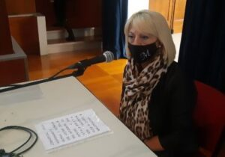
Maria Balsamo (lawyer Gatti) for the death of her husband Giancarlo Sboarina.
"My husband had just turned 40 when he died of mesothelioma. He was a very healthy person, a very strong young man. I lived in Chivasso, he lived in Casale. When we met, I was 14 and he was 21. We fell in love at first sight. "For a couple of years, we commuted: he came to me, then I went. Then I moved to Casale, at first to his parents' house, I was very young. Then , my mother moved in too. Until we got married in 1984, Giancarlo worked at Iarp: he started out as a worker, then became shop floor manager. His parents, on the other hand, were at Eternit. My father-in-law had asbestosis; he retired in 1971, but died at 55 because of asbestos. And my mother-in-law died the year before my husband. The terrible moment for Maria and Giancarlo came in 1996: 'In September, when we came back from holiday, he complained of a strong pain in his shoulders and back, and had a temperature. He was only 36 years old, just 36! And they found water in his lungs". Further investigations were carried out and "the diagnosis that should never have come" was given to us. From that moment on, 'life - Maria can no longer contain her tears - life was no longer life. Just as we were ready to live: we had two children, we wanted to buy our own house...'. At first, he didn't know about the disease: "I didn't want him to know. I used to wear masks at home to give him and the children strength. Then my mother-in-law passed away in January 1997. From then on, my husband began to understand. I took care of him until he died on 29 January. I my children were still young and he was gone’. Maria catches her breath, as if sucked in by the painful memory.
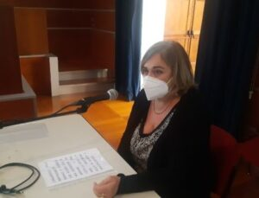
Antonella Migliaccio (lawyer Gatti) for the death of her mother Adriana Daniotti.
"When my mum got married, in July 1962, she was a a factory supervisor at Linclalor (a lingerie and underwear factory, ed.), but when I was born, the following year, she left her job and looked after the family. She was a wonderful woman!’Antonella starts sobbing. "She was full of energy and active, she went to the gym, she rode her bike with her friends and she helped others, so generous... In July 2010, when I came back from holiday and saw her, she was, how should I put it, no longer herself! She had been to the mountains over the weekend and wasn't feeling well. The local doctor had examined her and immediately understood: so she was sent for an X-ray. If you're from Casale Monferrato you know perfectly well what that means: that's a death sentence. And my mother felt overwhelmed, overcome by that sentence: she gave up. I saw her, in her pyjamas, sitting in a corner, looking down: no, she was no longer the same mother as always. After the biopsy, which confirmed the mesothelioma, she began to give me instructions: ' Give this to your aunt, this you give to...'". The provisions of her will. "She didn't want to undergo chemo, because she knew there was nothing to do, but we insisted, to look for hope. She was so sick." Antonella’s memories are vivid, fierce and unbearable. "When she was in bed, I stayed close to her and encouraged her to "sleep", because I hoped she would suffer less, but now I think I could have talked to her more instead...".
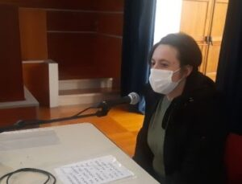

Anna Triglia (lawyer Gatti) for the death of her mother Luciana Morando.
"My mother used to live in Casale; as a girl she worked at the restaurant, the Osteria dei Pescivivi, which was my grandfather's, then, when she got married, she moved to Corso Manacorda... what is it? 700/800 metres from the Eternit factory... and then to Via Parodi. She was an only child; so, as well as looking after me and my father, she looked after her parents and an uncle, who lived in Salita Sant'Anna". A few hundred metres, as the crow flies, from the Ronzone plant. "And she also looked after my three children, not the fourth, because...Suddenly, quite unusually, she had gone to bed. In the last week of February 2015, she was not well, we thought it was a flu. But it didn't pass and tests were done: in April, we were given the diagnosis. In mid-May, she started chemo, but then it was stopped, she was sick. She passed away in mid-July of that year: there was no time to do anything else". And did she know how sick she was? "She knew, but she didn't want to mention it. She started to die when we went to see the doctor at the hospital. Those who live here in Casale know what it means." Anna chokes with tears. "Sorry, excuse me" she whispers, stifling her pain. "For treatment, my mum only wanted me and my dad, who was a Red Cross volunteer and knew what to do, by her side. I also took care of my grandmother and my uncle, who passed away during those months because my mother could no longer take care of them. I was pregnant with my fourth child: he was born three months after my grandmother's death’.

The municipalities (lawyer Esther Gatti).
The mayors on the witness stand: Davide Fabbri, from Ozzano; Cesare Chiesa from Rosignano; Marco Torriano from Balzola; Cesare Calabrese from Ticineto.
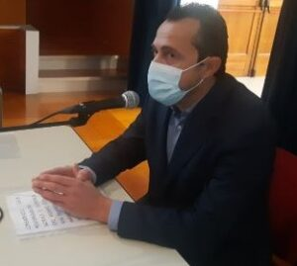
Davide Fabbri, Mayor of Ozzano

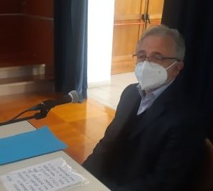
Cesare Chiesa, Mayor of Rosignano

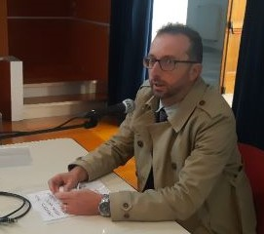
Marco Torriano, Mayor of Balzola
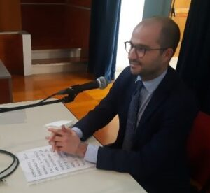
Cesare Calabrese, Mayor of Ticineto

A number of municipalities of the Monferrato, in the Casale district, have also joined the Eternit Bis trial as plaintiffs. At the hearing on Monday, November 8, four mayors (as Federico Riboldi, Mayor of Casale, had already done previously) spoke about the impact that asbestos has had - and continues to have – in their towns. They also spoke of the costs of dealing with asbestos and how it has affected their budgets. Rosignano presented accounting documentation that shows costs incurred, over one hundred thousand Euros; in Balzola so far, 159 thousand Euros of its own funds; in Ozzano, 150 thousand Euros. Ticineto will file the accounts shortly. In all cases, reclamation works carried out with state funding have to be added. "But it's not over," said Mayors Fabbri of Ozzano, Chiesa of Rosignano, Torriano of Balzola and Calabrese of Ticineto. While asbestos removal from buildings, squares and public roads is almost complete, in private homes we are nowhere near "asbestos free". And that's not all. "Above all, there is the seriousness of the human losses caused by the disease: an unspeakable tragedy both individually and for our communities. An enormous social impoverishment. And, again, asbestos has been and continues to block the development of these territories, because, "despite the fact that here we have cleaned up more than anywhere else in Italy, there is still a fear to move to our areas, either to live or to set up a business, and also a reluctance to be attracted by the tourist appeal of landscapes that are very beautiful, even listed as UNESCO heritage sites. We are struggling to get rid of the bad image, despite the many positive efforts and results already achieved, thanks, above all, cross party work in the local authorities over time, organisations and associations that place freedom from asbestos at the top of their list of priorities.
Next hearing on Monday 15 November
Some of the prosecution's consultants will be heard: the pathologis Drs Donata Bellis and Narciso Mariani and the clinicians Drs Massimiliano Bugiani (pneumologist), Pavilio Piccini (pneumologist) and Ferruccio Perrelli (occupational physician). The cross-examination of those same experts will take place at the next hearing.
https://www.silmos.it/voci-pacate-che-urlano-come-il-tuono-di-un-temporale-dagosto/

